Aswan High Dam
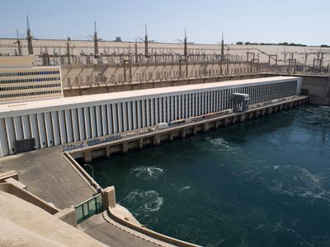
The Aswan Dam, shown in figure 1, is built on the River Nile, just south of the city of Aswan in Egypt and was completed in 1970.It is is a rock-fill dam, of 42 million cubic meters volume. The dam was constructed between 1960 and 1970. Its aim was to increase the amount of hydroelectric power and regulate the flooding of the Nile, making it safer for agriculture around the Nile banks and increase agricultural production. The Aswan High Dam is 3,830 meters long, 980 meters wide at the base, 40 meters wide at the crest (the top) and 111 meters tall. It contains 43 million cubic meters of material. At maximum, 11,000 cubic meters per second of water can pass through the dam. The reservoir, named Lake Nasser (named after Egypt's president at the time), is 550 km long and 35 km at its widest with a surface area of 5,250 square kilometers. It holds 111 cubic kilometers of water. The bridge was constructed at a cost of about $1 billion. The Aswan High Dam captures floodwater during rainy seasons and releases the water during times of drought. The dam also generates 10 billion kilowatt-hours of electricity every year.
Figure 1 Aswan High Dam
Mechanism
The Aswan High Dam generates electricity through a hydropower system. Firstly, the dam creates a large reservoir of water, in this case lake Nasser, then once the bridge starts generating electricity it releases the water into large tunnels called penstocks. The water flows downwards because of gravity and pressure increases as it travels through the penstocks. This high-pressure water then moves the turbine blades, causing the turbine to spin and rotate connected generators which generates electricity. After the electricity is generated, it is transmitted by high voltage power lines to the power grid. The power plant at the Aswan Dam has a nominal capacity of 2,100 MW and is thus the largest power plant in Egypt. In 2015, the dam produced 5.68% of the Egyptian electricity supply and the production of electric power from the High Dam is 10 milliard kwh annually, which is double the amount generated in Egypt before the construction of the Dam.
Points of Strength

Increased Agricultural Production
Aswan High Dam has allowed farming to continue, even during drought years e.g. 1972 and 1973. This reduced the dependency on food imports. Furthermore, 3.4 million hectares have been irrigated by the Nile, which increased the agriculture output of Egypt

Flood Control
The High Dam limited the floods that hit the Nile Banks and ruined crop production in upper Egypt by blocking any incoming flood waves, it also saved lives in 1965, 1965, 1975 and 1987. Also, less flooding means that there are no flood repair costs, and insurance premiums are also cheaper.

Economic Benefits
The construction of the Aswan High Dam provided job opportunities to workers, engineers and construction companies used in constructing the dam. Furthermore, the maintenance of the Dam provided stable jobs for more Egyptian workers and The Dam itself has become an important tourist attraction along with the temples that line the river, which increases the overall income and economic benefit of this Dam.

Points of Weakness

Demographic Changes
Up to 100,000 Nubian (indigenous Egyptians) were forced to move from their ancestral homes. This damaged the Nubian Culture in Egypt and triggered multiple Nubian revolts to prevent the Dam from getting built.

International Conflicts
Currently Egypt and Sudan get 90% of the Nile's water. Other countries that the Nile flow through are unhappy and have asked for more. This could lead to conflict, such as conflict between Egypt and Ethiopia and other countries along the Nile River.

Environmental Impacts
Fertilizers, chemicals and waste is no longer flushed away by the Nile's annual floods. This is because of the High Dam’s structure as it only allows passage of water. Furthermore, it is estimated that $100 million worth of artificial fertilizers have to be used every year to replace the nutrients (alluvium) trapped behind the dam. This obviously has an economic cost, but there is also the environmental cost of using chemicals and possibly the social cost of people consuming the chemicals.

